WEEK 4

Order and Order Details Management System
Student Name: Maria Jency
Course: Bachelor of Computer Applications (BCA)
Project: E-Commerce Database Management
Week: 4
Database: ecommerceD__B
Technology: MySQL

1. Abstract
This project focuses on analyzing order management in an e-commerce database. SQL queries are used to retrieve customer orders, product details, order quantities, sales values, and customer spending information.

2. Aim
To perform order management and generate useful reports using SQL queries.

3. Implementation
The existing e-commerce database was used without recreating its tables. The Orders table was joined with the Customer table to retrieve customer order information. The Order_Details table was joined with the Product table to identify products included in each order.
Aggregate functions were used to calculate total quantities, sales values, customer spending, and average order value. GROUP BY and HAVING were used for summarized reports, while CASE was used to classify orders based on their total amount.

4. Reports Generated
- Complete order records.
- Order details with customer information.
- Products included in each order.
- Total items in each order.
- Customer-wise order count and spending.
- Product-wise quantity sold and sales value.
- Order status summary.
- Average order value.
- High, medium, and low-value order classification.

5. Result and Output
The SQL queries were designed to generate reports from the existing e-commerce database. Actual output depends on the records available in the database.
Screenshot 1: Orders table output.
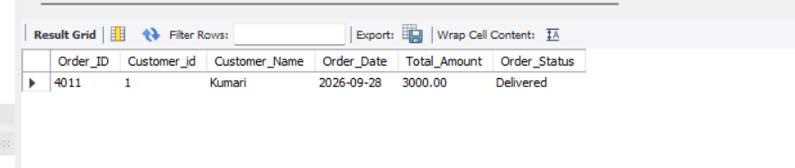
Screenshot 2: Customer and order JOIN output.
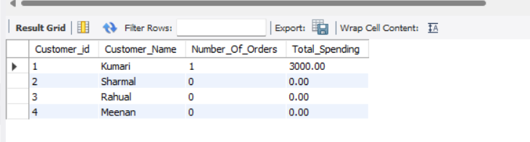
Screenshot 3: Product-wise sales report.
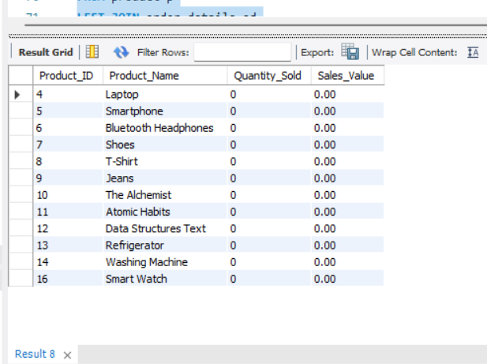
Screenshot 4: Customer spending summary.
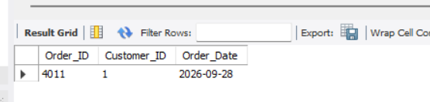
Screenshot 5: Order status summary.
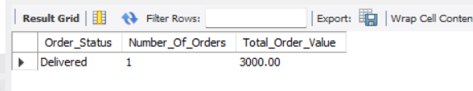

6. Conclusion
The Week 4 project demonstrates practical SQL database analysis using joins, aggregate functions, grouping, and conditional statements. It provides useful information about customer orders, product sales, and order performance.

7. Future Enhancement
The project can be extended with inventory tracking, automated order status updates, sales dashboards, and customer purchase analysis.

